First go to Theme Designer screen via transaction /UI5/THEME_DESIGNER.. Theme Designer will be opened in your default browser..

[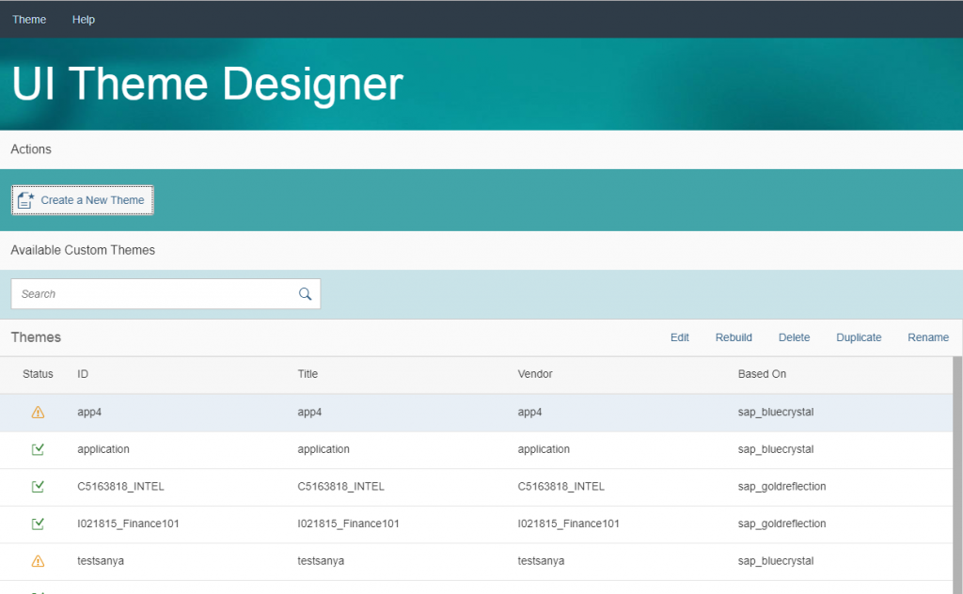](http://zyndanismanlik.com/wp-content/uploads/2019/10/1-1.png)

Click on Create a New Theme button and select a base theme and click Step 2 button..Your new theme will completely be the same with the base theme..

[metin içeren bir resim

Açıklama otomatik olarak oluşturuldu](http://zyndanismanlik.com/wp-content/uploads/2019/10/2-1.png)

Give ID and Name for your new theme and click Create Theme button..

[metin içeren bir resim

Açıklama otomatik olarak oluşturuldu](http://zyndanismanlik.com/wp-content/uploads/2019/10/3-2.png)

Add your FLP as target page

[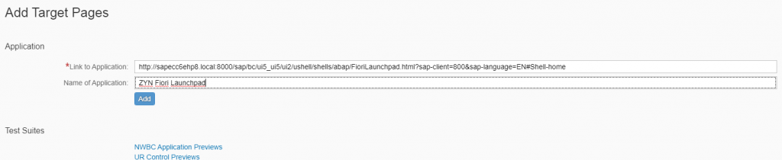](http://zyndanismanlik.com/wp-content/uploads/2019/10/4-1.png)

And select your company logo

[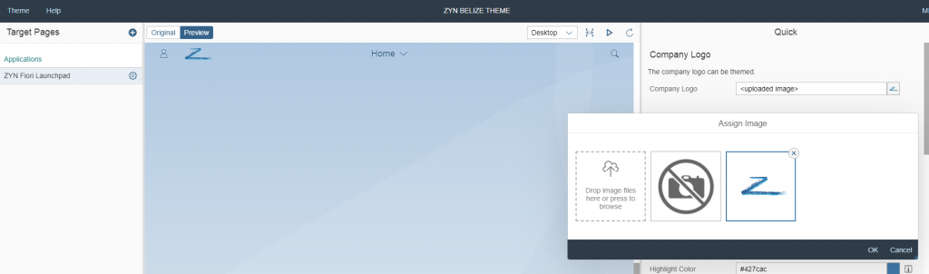](http://zyndanismanlik.com/wp-content/uploads/2019/10/5-1.png)

Save&Build your new theme

[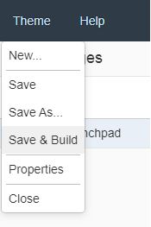](http://zyndanismanlik.com/wp-content/uploads/2019/10/6-1.png)

Now, in User Settings of Fiori Launchpad you can see your new theme and set as default theme for your user..

[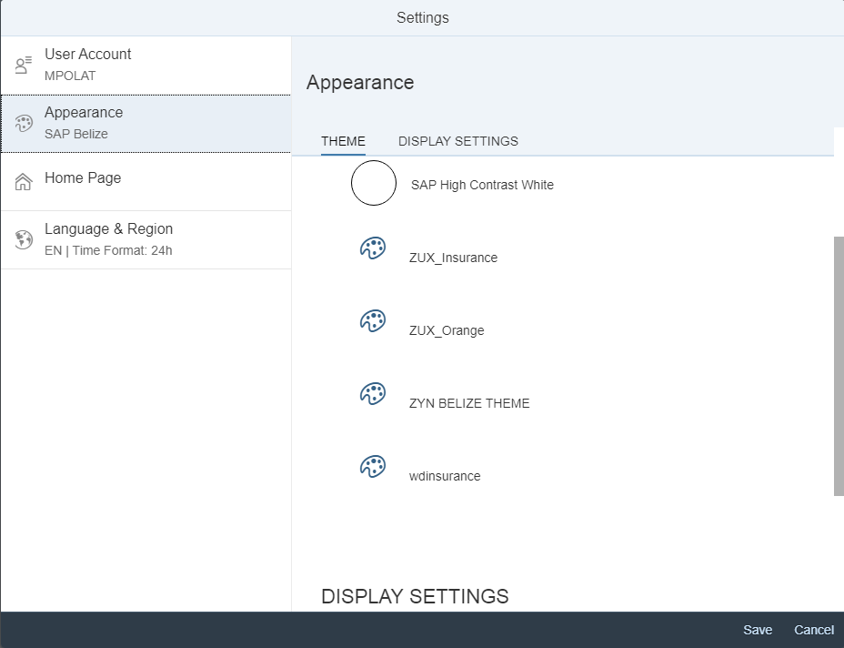](http://zyndanismanlik.com/wp-content/uploads/2019/10/7-1.png)

If you want this theme to be default for all users, go to transaction /UI2/NWBC_CFG_CUST and create a new parameter SAP_FLP – THEME with the ID of your new theme..

[metin içeren bir resim

Açıklama otomatik olarak oluşturuldu](http://zyndanismanlik.com/wp-content/uploads/2019/10/8-1.png)

And voila..

[](http://zyndanismanlik.com/wp-content/uploads/2019/10/9.png)